Project Design Phase-II
Data Flow Diagram & User Stories

Date | 7/03/2026
Team ID | SWTID-2026-6317
Project Name | Product Inventory Management
Maximum Marks | 4 Marks

Data Flow Diagrams:
A Data Flow Diagram (DFD) is a graphical representation that shows how data moves through a system. It illustrates how information enters the system, how it is processed, and where it is stored. DFD helps in understanding the system requirements clearly by showing the flow of data between different processes, data stores, and external entities. It makes the system structure easier to analyze and design.

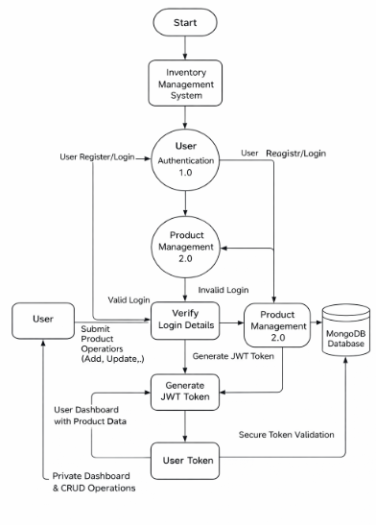

User Stories
Use the below template to list all the user stories for the product.
User Type | User Story Number | User Story / Task | Acceptance Criteria | Priority | Release
Customer (Web User) | USN-1 | As a user, I can signup and access the system securly | User account is created successfully and login authenciated | High | Sprint-1
Customer (Web User) | USN-2 | As a user, I can add new products to my inventory | Product details are added and saved in database | High | Sprint-1
Customer (Web User) | USN-3 | As a user, I want to see a list of all my stored products | System displays all products linked to the logged-in user | High | Sprint-1
Customer (Web User) | USN-4 | As a user, I can update product details like price and quantity | Changes are saved and reflected instantly | Medium | Sprint-2
Customer (Web User) | USN-5 | As a user, I want to remove unnecessary products from my list | Product is permanently deleted from the system | Medium | Sprint-2
Customer (Web User) | USN-6 | As a user, I can search products by name | Filtered results appear based on keyword | Low | Sprint-2

